Final Project/Exam Spanish 2-AP

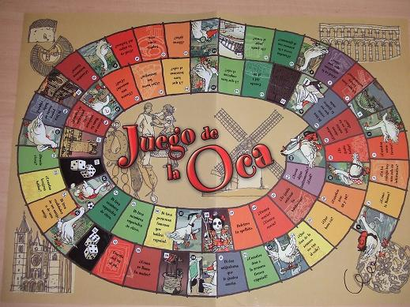
Your final for Spanish this year will entail you creating a board game that must cover all of the material in column A, B, or C below, which we have covered this year. The de sign of your game can be based on something that already exists (e.g. Monopoly, Life, Trivial Pursuit, etc), on a combination of these games, or on a brand new idea from you. You will have to have all the elements of a game: the board, the game pieces, any cards (e.g. “chance” and “community chest”), and a booklet explaining the object and rules of the game, etc. Finally, you will have to present the material to the class (in Spanish of course) as if you were the game designers for a gaming company (e.g. Milton Bradley, Parker Brothers, Hasbro, etc.) and you were presenting this new game to the board of trustees who will then approve, or not, the game. On the last day of class before exams, we will play the games, via rotation, that have been designed by your peers.

Each board game made must have the following items included:
- Practical/Physical:
  - Actual playing board: including game pieces and any necessary devices to complete your designed game
  - Game theme, questions, statements, layout, design must be in Spanish
  - Rules and Directions: The rules must be written out, understandable, and applicable to the game you created
  - Your board game must be playable-you will have a chance to play each other’s games later
  - Basics of the game:
    - How is it played?
    - Number of players
    - Objective
    - How to reach the objective.
- Knowledge
Topic \ Class | Spanish 2 | Spanish 3 | AP
Grammar | - Object Pronouns  - Pretérito  - Imperfecto  - Pret/Imp juntos  - Presente Subjuntivo  - Mandatos  - Por/Para  - Pronouns  - Reflexive  - Relative  - Possessives  - Object (Dir/Ind)  - Presente Perfecto | - All in Spanish 2  - Comparativos  - Superlativos  - Expresiones Negativas  - Futuro Simple  - Pasado Perfecto  - Diminutivos  - Aumentativos  - Condicional  - Imperfecto del Subjuntivo | - All in Spanish 3  - Pluscuam Indicativo  - Pluscuam Subjuntivo  - Futuro Perfecto
Vocabulary | - Health & Medical  - Parts of the body  - Home electronics  - Cars  - Homes  - Chores  - Environment/Nature  - Money/Banking  - Nutrition / Health | - Salud/Bienestar  - Medicos/hospital  - Viejes/alojamiento  - Excursiones  - Naturaleza  - Animales  - Medioambiente  - Tecnología  - Profesiones  - Inventos  - Trabajo  - Economía y Finanzas
Culture et Al | - Argentina – Tango  - Nada  - Patio Central  - Los Andes  - Los Metros | - Rubén Blades  - Gabo  - Bobo del Móvil  - Ruta del Café  - Canal de Panamá  - Bosques del Mar | - El Principito  - Poema XX  - El Gato de Sevres  - Canción del Pirata  - No Oyes Ladrar…

- Please note that you do not have to include EVERYTHING listed above in your game, but everything that is in your game should be representative of all the categories listed above.
- Layout/Creativity
  - Be neat, clean cut, professional, and organized
  - Creative, colorful and pretty! Who wants to play a game with no character?!
- You must present the game, in Spanish, to the class. You will include in your presentation:
  - Sell the game to us, why should we play it.
  - What does the game do? What’s the purpose of the game?
  - How is our knowledge from the year present in the game?
  - How will the game benefit our knowledge/retention of knowledge/review of knowledge of Spanish 2?
  - Why is this a good/fun game?

Important Dates
- 11 de mayo Project Proposal Due (p.3 of this packet)
- 11-22 de mayo Project Work Time
- 26-27 de mayo Group Presentations

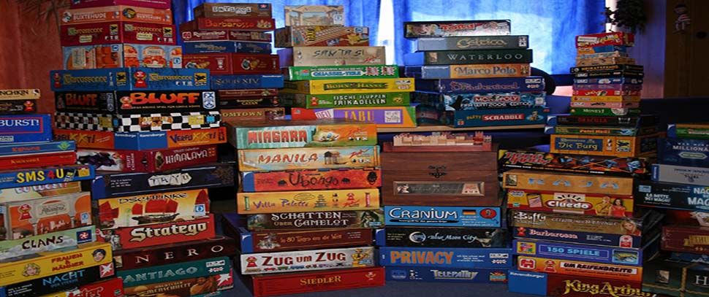

Game Design Project
Project Proposal

Names: __________________________________________ __________________________________________

__________________________________________ __________________________________________

In your group, decide the following information for your game project. You will be required to turn this in by May 1stand stick to it (for the most part, some changes are bound to take place) on your final project.

Game Title
Format
Number of Players
Who Goes First?
Length of Game
Object/Purpose
“How to win”
Equipment Needs
Rules of the Game

Game Design Project
Grading Rubric

Categoría (A) | 10 | 9 | 8 | 7 | 6 | 0 | Total
I. Escritura y Juego
1. Gramática Escrita |  |  |  |  |  | No existe
2. Vocabulario Escrito |  |  |  |  |  | No existe
3. Profundidad de Conocimiento |  |  |  |  |  | No existe
4. Creatividad |  |  |  |  |  | No existe
5. Diseño |  |  |  |  |  | No existe
6. Instrucciones Claras |  |  |  |  |  | No existe
7. Complexidad |  |  |  |  |  | No existe
8. Detalles |  |  |  |  |  | No existe
II. Presentación
1. Gramática Oral |  |  |  |  |  | No existe
2. Vocabulario Oral |  |  |  |  |  | No existe
3. Profesionalismo |  |  |  |  |  | No existe
4. Material Auxiliar |  |  |  |  |  | No existe
5. Minuciosidad |  |  |  |  |  | No existe
6. Conocimiento del Material (sin leer) |  |  |  |  |  | No existe
III. Contenido
1. Pretérito |  |  |  |  |  | No existe
2. Imperfecto |  |  |  |  |  | No existe
3. Se impersonal |  |  |  |  |  | No existe
4. Imperativo |  |  |  |  |  | No existe
5. Por / Para |  |  |  |  |  | No existe
6. Reflexivos Recíprocos |  |  |  |  |  | No existe
7. Adj/Pron Posesivos |  |  |  |  |  | No existe
8. Pronombres Relativos |  |  |  |  |  | No existe
9. Presente Subjuntivo |  |  |  |  |  | No existe
10. Presente Perfecto |  |  |  |  |  | No existe
11. Pasado Perfecto |  |  |  |  |  | No existe
12. Cultura: Capítulos 1-6 |  |  |  |  |  | No existe
13. Literatura: Capítulos 1-6 |  |  |  |  |  | No existe
 |  |  |  |  |  | Gran Total

A = 242 B = 214 C = 188 D = 161

