Project: Fiestas de Fin de Año

General Information
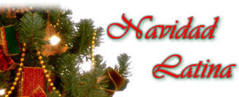
There are two parts of this project. First, you will research one of the topics below and present the topic to the class with an oral presentation (Spanish 1 in English, Spanish 3 in Spanish), and at least one audiovisual mode (poster, iMovie, PowerPoint, cooking, etc.). Second, you will sing (yes, SING) as a caroling group as part of a multilingual choir singing end of year songs.

Grading

Component Due/Presented Points
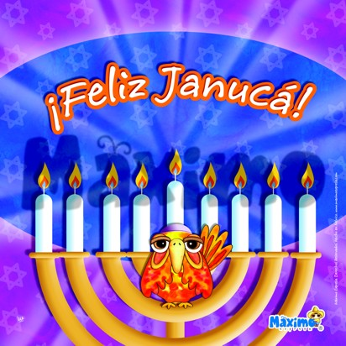
Oral Presentation 12/13 de diciembre 35

Audiovisual/Prop 12/13 de diciembre 15
Presentation Total 50

+Choral Presentation 18/19 de diciembre 25
Project Total 75

Topics
You may choose ONLY ONE topic and once the topic is chosen, no other person (in ANY of my classes) may choose the same topic. So please act quickly in order to choose the topic in which you are most interested. If a food, you can either pick one and do an in-depth study (maybe even bring in a sample!) or you can take a pair of topics (i.e. 2 drinks) and compare/contrast them.

- Aguinaldos (the games – Colombia)
- Aguinaldos (the gifts)
- Foods (Pick 1):
  - Ajiaco
  - Arrollado
  - Buñuelos
  - Cazuela de Ave
  - Cola de Mono
  - Hallacas
  - Lechón Asado
  - Niños Envueltos
  - Pan de Pascua
  - Panettone
  - Ponche Crema
  - Rosca de Reyes
  - Tamaladas
  - Tembleque
  - Turrón
- Árbol de Navidad
- Burning Effigies
- Epiphany/Reyes and gifts/Balthasar
- Gaitas (Venezuela)
- Hanukkah in México, Argentina or Spain
- La Bruja Befana
- La Novena de Navidad
- Las Velitas
- Los Seises
- Misa de Gallo
- Octavas / Octavitas
- Parrandas
- Pastorelas
- Pesebre
- Poinsettias
- Posadas
- Viejo Pacuero y los Zapatos
- Papa Noel v. Niño Jesús
- Villancicos
- Warini (Honduras)
- New Year’s Traditions (Pick 3)
  - Undergarment colors
  - Suitcase around the block
  - 12 Grapes
  - Lentils
  - Opening front and back door
  - Bucket of water
  - Vitel Toné
  - Cotillones de Noche Vieja
  - La Pólvora (Fireworks)

