Vocabulario Literario
Nada (fragmento), por Carmen Laforet
Castellano 2
Abril 2015

- acera ________________________________
- adquirir billetes ________________________________
- agitando ________________________________
- agradable ________________________________
- almas ________________________________
- antiguo ________________________________
- apartada ________________________________
- armatoste ________________________________
- arracimarse ________________________________
- asombro ________________________________
- asustada ________________________________
- atravesé ________________________________
- azotaba ________________________________
- borrachos de soledad ___________________________
- camàlics ________________________________
- cerebro ________________________________
- corriente ________________________________
- crujir ________________________________
- cuchicheo ________________________________
- de improvise ________________________________
- derecho ________________________________
- desconfiada ________________________________
- desconocida ________________________________
- desvencijado ________________________________
- enfilamos ________________________________
- ensueños ________________________________
- entumecidas ________________________________
- envolvía ________________________________
- espalda ________________________________
- espeso verdor ________________________________
- estela ________________________________
- faroles ________________________________
- filosofía y letras ________________________________
- fuerza ________________________________
- gota ________________________________
- guerra ________________________________
- madrugada ________________________________
- me conmovió ________________________________
- olor ________________________________
- pulmones ________________________________
- repercutía ________________________________
- retraso ________________________________
- risueño ________________________________
- ruido ________________________________
- rumbo ________________________________
- sangre ________________________________
- se cargaba de ________________________________
- se detuvo ________________________________
- se lanzaba ________________________________
- se volcaba en ________________________________
- sola ________________________________
- titubear ________________________________
- tranvía ________________________________
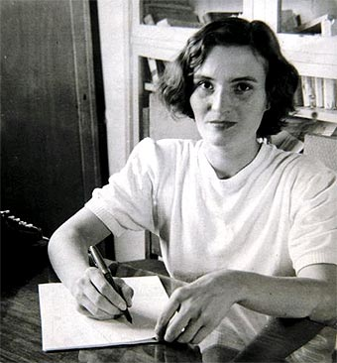
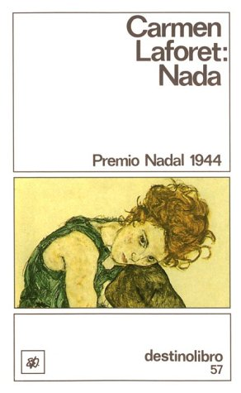
- vacías ________________________________

