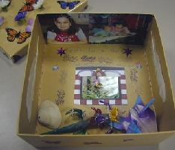
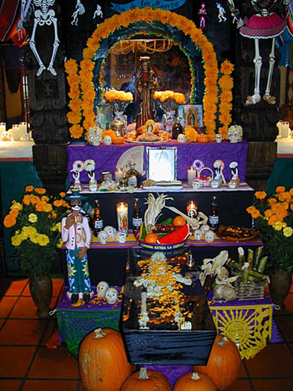
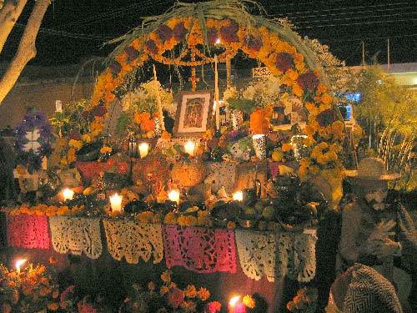

Un proyecto para el día de los muertos

Las ofrendas:
The Day of the Dead ofrenda, or altar, is a pre-Hispanic tradition that has lasted centuries. It has become an integrated part of the Catholic religion in Mexico and Central America. Every year it becomes a bigger and bigger event, with school classes, government employees and artists throughout Mexico competing for the most creative and interesting ofrenda. Halloween is not a tradition in Mexico, and every year the Catholic church fights against the celebration and promotes the ofrendas for el dia de los muertos. Ofrendas are made on November 1st for santos inocentes, children who have died, and on November 2nd for adults who have passed away.

Your project:
Your class will make a community ofrenda for loved ones who have passed on. It can be personal, such as a classmate or teacher, or it can be impersonal, such as Elvis, Princess Diana, or Selena, for example. Once you decide who you will honor with your ofrenda, you will need to design it. You will also write a poem addressed to the person you have chosen. This poem will be turned in to me and, if you have her as your English teacher, to Ms. Jurskis.
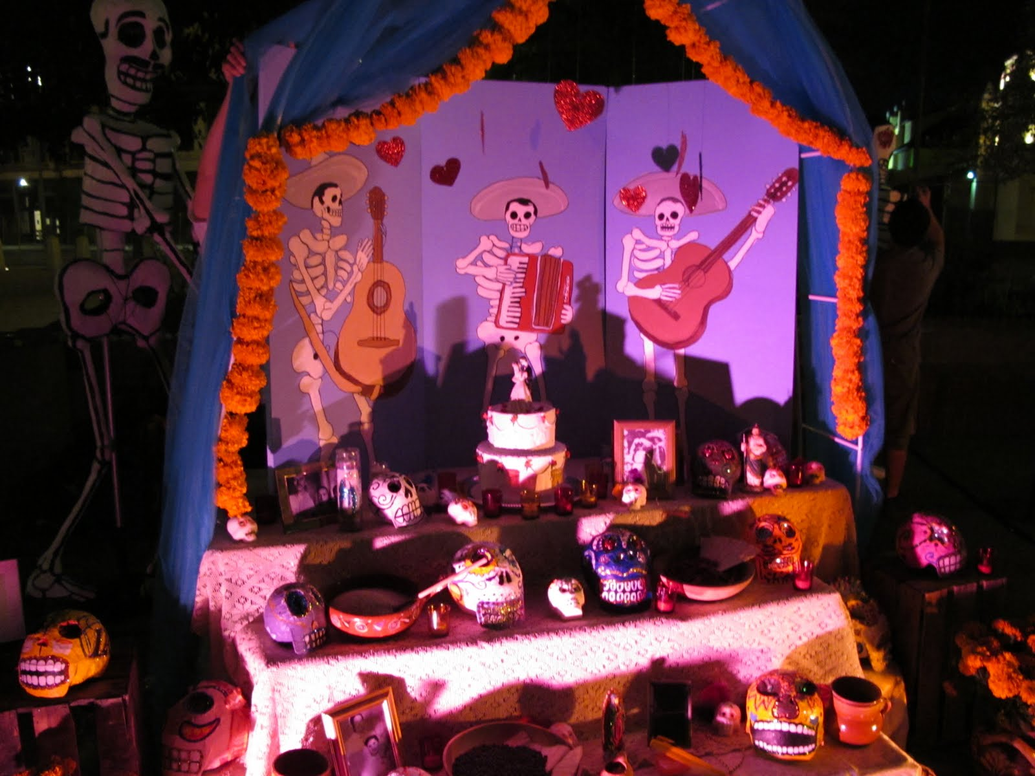

Building your ofrenda:
Don't feel like you need to go out and buy these materials. Be creative and do the best you can with the resources we have at school, and you may have at at home.

1. The most important thing to put on your ofrenda is a photograph of the person to whom you are dedicating the ofrenda. The ofrenda is covered in "papel picado" which is brightly colored tissue paper with cut out designs. We will make papel picado in class for you to use. Three important colors are purple (for pain), white (for hope), and pink (for the celebration).

2. Candles are also placed all over the ofrenda (do not light them, please). Four candles need to be placed on the top level of the altar signifying the four cardinal points. The light from the candles illuminate the way for the dead upon their return.

3. Three skulls are placed on the second level. These represent the Holy Trinity. A large skull is placed on the center to represent the Giver of Life. All bad spirits must be whisked away and leave a clear path for the dead soul.

4. The Day of the Dead bread, pan de muerto, should be accompanied by fruit and candy placed on the altar. Pan de muerto is plain, round sweet bread sprinkled with white sugar and a crisscrossed bone shape on top. You can also add the person 's favorite food(s).

5. A towel, soap and small bowl are put on the altar so that the returning spirit can wash its hands after its long trip. There is a pitcher of fresh water to quench its thirst and another beverage.

6. To decorate and leave a fragrance on the altar, the traditional cempasuchil flower (marigold) is placed around the other figures. Cempasuchil comes from the Nahuatl word cempoalxochitl, which means the flower with four hundred lives. The flower petals form a path for the spirits to bring them to their banquet. (Potpourri may be an idea, too... )

Writing Your Conjure Poem
- Select the person who has died to whom you want to address your poem
- Write down a smell or scent you associate with this person
- Name a food or drink or taste of something they loved to eat or drink
- Write down a sound you associate with them. This can be music or the sound of them hammering or sweeping or chopping in the kitchen, a car horn, a whistle, a laugh, a cough, anything
- Remember a favorite article of clothing, a sweater, a pair of shoes they always wore/ Write those down.
- Was there a favorite saying they had? Something you associate with them, a nick name, a way of teasing? How would they greet you?
- What would you say to them if they came back? What might they say to you?
- What activity might you do together? Who else, if anyone, would join you?

Starting to write:
- You might think of this as an informal letter to this person. Address them by name for eg. Tio Manuel. Or a nickname or term of endearment like Grammy
- Some possible starts are “When you come back....” or a direct appeal, “Come back...”
- The memories and details from their lives are what you are offering as the lure to bring them back. Let them know what will happen if they return.

Some Ideas:

- Ehow has several articles related to Day of the Dead ofrendas and nichos.
- How to Build a Day of the Dead Shrine is largely about ofrendas, and includes the basic elements. The author mentions that it's acceptable to use just a photo of the person being honored, surrounded with candles and flowers, if you can't build a full shrine. You can put as many photos of different people as you wish on your basic shrine.
- How to Make a Shrine for Day of the Dead stresses the importance of using items that were favorites of the deceased: clothing, belongings, or things like cigarettes, cards, and items that have to do with their best-loved activities.
- How to Decorate for Day of the Dead has similar information, but expands it through the entire house and a visit to the cemetery.
- How to Make Religious Nichos has some ideas for nichos that you can make as part of your ofrendas.
- Make Your Own Altar at 1-2-3 Holiday has even more detailed information, though it contradicts some information that I've read elsewhere. It doesn't seem that the rules listed here, such as the number and placement of candy skulls, are rigid ones.
- If all of this seems too complicated for you, try this tutorial from DIY Network: during one of Kathy Cano-Murillo's appearances on Craft Lab, they made a nicho-type cigar-box shrine.

Rubric:

Ensayo: 35pts 11/01//11

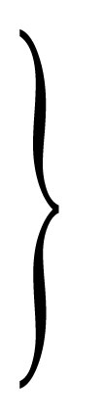
Cultural Presence: 20pts
Class Presentation: 30pts 11/01/11
Quality of Work: 15pts
Total: 100pts

